**CHAPTER 1**

**INTRODUCTION**

* 1. **Introduction**

Kids’ Quiz Zone website, helping users test and expand their knowledge on various subjects for learning. Enhancing critical thinking and recall abilities through interactive questions for skill development. Building a community of trivia enthusiasts who can discuss and share quiz topics. Our platform offers a diverse array of quizzes designed to entertain and educate users of all ages. From trivia on history and science to pop culture and sports, there's something for everyone. Whether you're looking to test your knowledge, challenge friends, or simply have fun, our user-friendly interface makes it easy to jump right in. Join our vibrant community and discover the joy of learning through quizzes, where every question is an opportunity to expand your horizons!

* 1. **Motivation**

Our motivation is to create an engaging and enriching experience for users through the power of quizzes. We believe that learning can be both fun and rewarding, which is why we strive to offer a wide range of topics that spark curiosity and foster knowledge. Our goal is to challenge minds, inspire friendly competition, and build a community of learners who enjoy discovering new things together. By making education interactive and enjoyable, we aim to cultivate a lifelong love for learning in everyone who visits our site**.**

* 1. **Aim and Objectives**

The aim of Kids’ Quiz Zone is to provide an engaging platform that fosters learning and entertainment through a diverse range of quizzes, encouraging users to explore and expand their knowledge.

Objectives:

1. **Diverse Content**: To offer a wide variety of quizzes covering multiple subjects and difficulty levels to cater to different interests and expertise.

2. **User Engagement**: To create an interactive environment that encourages users to participate, challenge friends, and share their quiz results.

3**. Educational Value**: To promote learning by providing accurate information and educational insights through our quiz questions.

4. **Community Building:** To cultivate a supportive community of quiz enthusiasts who can connect, share knowledge, and engage in discussions.

* 1. **Overview of the System**

This website is designed to provide users with an intuitive and engaging quiz experience. The system features a user-friendly interface that allows easy navigation through a diverse selection of quizzes across various categories, including history, science, pop culture, and more. Users can create accounts to track their progress, save their favorite quizzes, and participate in leaderboards to encourage friendly competition. The system supports multiple question formats, such as multiple-choice, ensuring a dynamic learning environment.

* 1. **Organization of the Research**

The research for Kids’ Quiz Zone is organized into several key steps:

1. Literature Review: We study existing quiz platforms to learn from their strengths and weaknesses.

2. User Surveys: We gather input from potential users about their interests and preferences for quizzes.

3. Content Development: We work with experts to create accurate and engaging quiz questions.

4.Give Certificate: If you hit 10 out of 15 questions, you will receive a certificate.

**CHAPTER-2**

**TECHNOLOGY BACKGROUND**

**2.1 Web Technology**

**2.1.1 Web Application**

Main technologies associated with RSTEL project are

* web programming technologies (Advanced Java (J2EE), Jakarta Server Pages (JSP), JavaScript (JS), Hypertext Market Language (HTML, CSS)
* MYSQL (Database)
* MYSQL Workbench (Diagram)

**2.1.2 Client Server Architecture**

The Web Technologies used in RSTEL project are detailed

following below.

1. **Java J2EE (Java 2 Platform, Enterprise Edition):** A powerful platform for building enterprise applications.
2. **Java Servlets:** Learn how to build web applications with Java Servlets, which are used to handle HTTP requests and generate dynamic web content.
3. **Java Server Pages (JSP):** Learn how to create dynamic web pages using JSP, which combines HTML and Java code.
4. **JavaScript:** It is a high-level, interpreted programming language primarily used for creating interactive effects within web browsers. It can also be used server-side, for example, through Node.js.
5. **HTML (Hypertext Markup Language):** It is a standard markup language used for creating web pages. It describes the structure and content of a webpage, including text, images, links, and more.
6. **CSS (Cascading Style Sheets):** It is a style sheet language used for describing the look and formatting of a document written in HTML. It controls layout, colors, fonts, and other visual aspects of a webpage.

**2.2 Apache Tomcat Web Server**

Apache Tomcat is an open-source web server and servlet container developed by the Apache Software Foundation. It is used primarily for deploying and managing Java-based web applications. Tomcat implements the Java Servlet, Java Server Pages (JSP), WebSocket, and Java Expression Language (EL) technologies, providing a robust environment for running web applications written in Java.

**Some key features of Apache Tomcat include:**

**Servlet Container:** Tomcat functions as a servlet container, providing an environment for Java servlets to run in. Servlets are Java classes that handle requests and generate dynamic web content.

**JSP Support:** Tomcat supports Java Server Pages (JSP), which are web pages that contain static content as well as Java code snippets for dynamic content generation.

**HTTP Server:** Tomcat can also function as a standalone web server, capable of serving static content such as HTML, CSS, and JavaScript files.

**Integration with other Apache Projects:** Tomcat can be integrated with other Apache projects such as Apache HTTP Server for load balancing and reverse proxying.

* 1. **MySQL Database Server**

MySQL is an open-source relational database management system (RDBMS) developed by Oracle Corporation. It is one of the most popular databases in the world, widely used for managing and storing data in various types of applications, ranging from small-scale websites to large enterprise systems.

Key features of MySQL include:

**Relational Database Management System:** MySQL is based on a relational database model, allowing users to define tables, columns, and relationships between data entities. It supports SQL (Structured Query Language) for querying and manipulating data.

**High Performance:** MySQL is known for its performance and efficiency in handling read and write operations. It employs indexing, caching, and other optimization techniques to improve query execution times and overall database performance.

**Security Features:** MySQL provides robust security features to protect data integrity and confidentiality. This includes access control mechanisms, user authentication, encryption support, and auditing capabilities to monitor database activity.

**Community Support and Ecosystem:** MySQL has a large and active community of developers, users, and contributors who provide support, documentation, and resources for troubleshooting and optimization. Additionally, there are many third-party tools, libraries, and extensions available to extend MySQL's functionality.

**Open-Source Licensing:** MySQL is distributed under an open-source license, making it freely available for download, use, and modification. This open-source nature has contributed to its widespread adoption and popularity in the software development community.

Overall, MySQL is a powerful and flexible RDBMS that can support a wide range of applications and use cases.

**2.4 MySQL Workbench**

MySQL Workbench is a visual tool for database architects, developers,

and DBAs. It provides a graphical interface for designing, creating, and maintaining MySQL databases.

One of the key features of MySQL Workbench is its Diagram tool, which allows users to create visual representations of their database schemas. The diagrams help users to understand the relationships between different database objects, such as tables, views, and stored procedures.

Some of the benefits of using MySQL Workbench Diagram include:

* Easily visualize complex database schemas.
* Improve collaboration among team members by providing a clear visual representation of the database design.
* Simplify database documentation and maintenance.
* Accelerate the development process by allowing users to create and modify database objects directly from the diagram.

MySQL Workbench Diagram is a powerful tool for database professionals, providing a user-friendly interface for designing and managing complex databases.

**CHAPTER 3**

**SYSTEM DESIGN**

**3.1 Overview of the System**

The quiz website system features a user-friendly interface for easy navigation, with a home page showcasing highlighted quizzes and categorized subjects. It includes an admin panel for managing quizzes, allowing for the creation and editing of various question types. Users can login account. Users get the results of quizzes after answering the questions, then if users reach the limited score, users get a certificate.

**3.2 System Flow Diagram**

The system flow diagram illustrates the authorized sections of the admin and users.

**3.2.1 Admin View**

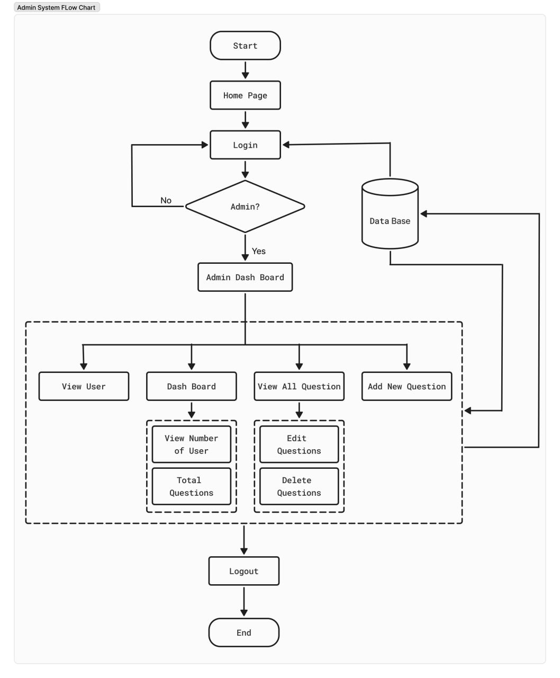

**3.2.2 Guest User View**

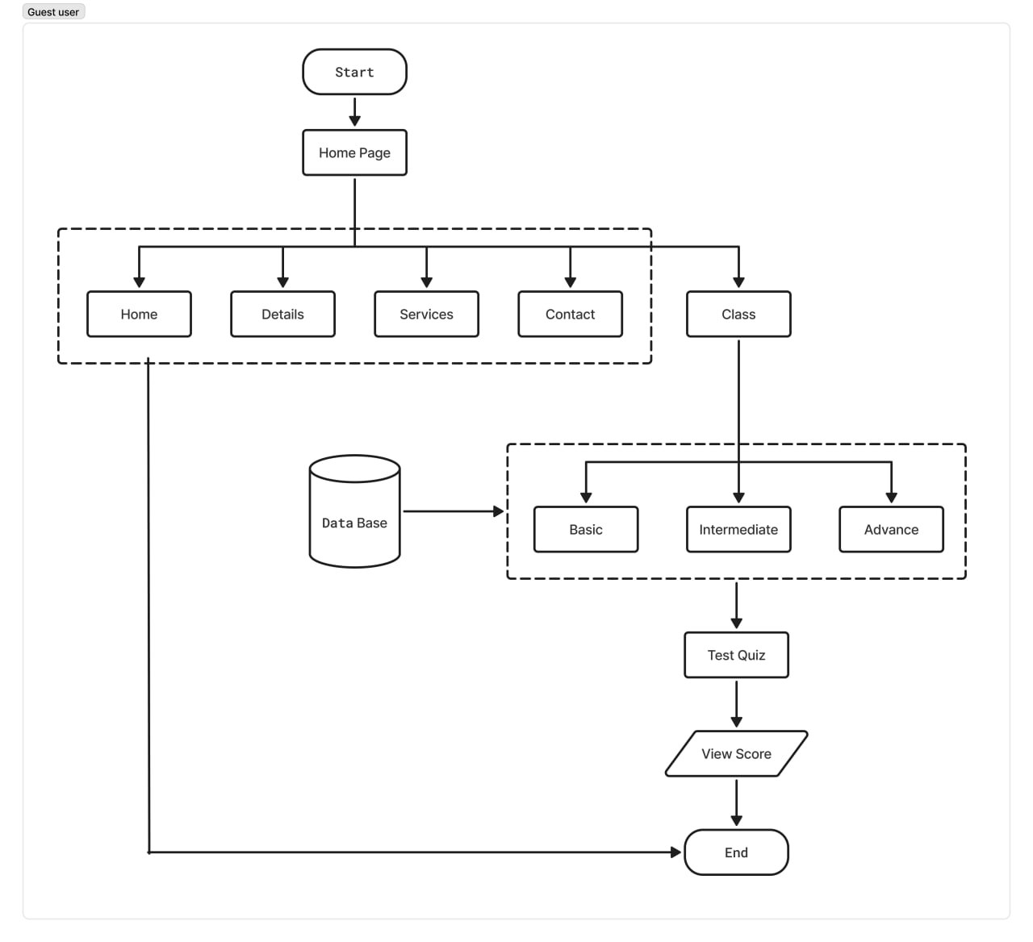

**3.2.2 Login User View**

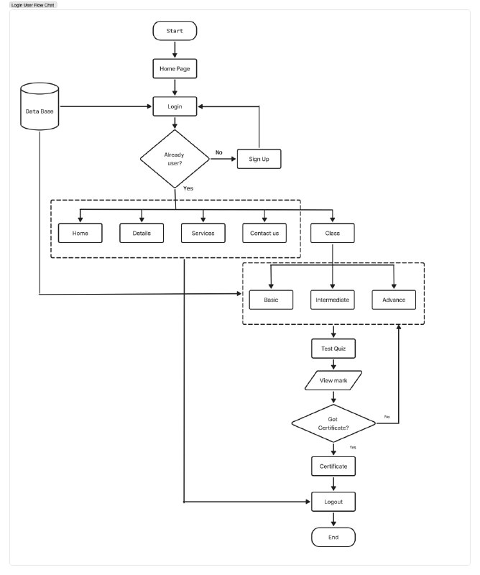

**CHAPTER 4**

**SYSTEM IMPLEMENTATION**

**4.1 Database Design**

The database design would typically include several key entities and their relationships. This proposed system includes three tables. They are level table, quiz table, user table.

**4.1.1 Level Table**

The level table of this system is represented in the database with the attributes levelid (int, not null, primary key), level name (varchar(50)).

The level table is created as follow:

|  |  |  |  |  |  |
| --- | --- | --- | --- | --- | --- |
| Field | Type | Null | Key | Defaut | Extra |
| levelid | int | NO | Primary Key | Null |  |
| levelname | Varchar(45) | YES |  | Null |  |

**4.1.2 Quiz Table**

The quiz table of this system is represented in the database with the attributes quizid (int, not null, primary key, auto_increment), question(varchar (500)), option1 (varchar(100)), option2 (varchar(100)), optiono3 (varchar(100)), correctanswer (varchar(100)), levelid(int, not null, foreign key).

The quiz table is created as follow:

|  |  |  |  |  |  |
| --- | --- | --- | --- | --- | --- |
| Field | Type | NULL | Key | Default | Extra |
| quizid | INT | NO | Primary Key | NULL | auto_increment |
| questions | VARCHAR(500) | YES |  | NULL |  |
| option1 | VARCHAR(100) | YES |  | NULL |  |
| option2 | VARCHAR(100) | YES |  | NULL |  |
| option3 | VARCHAR(100) | YES |  | NULL |  |
| correctanswer | VARCHAR(100) | YES |  | NULL |  |
| levelid | INT | NO | Foreign Key | NULL |  |

**4.1.2 User table**

The user table of this system is represented in the database with the attributes userid ( int, notnull, primarykey, auto_increment), name (varchar(45)), email(varchar(45)), password(varcahr(45)).

The user table is created as follow:

|  |  |  |  |  |  |
| --- | --- | --- | --- | --- | --- |
| Field | Type | NULL | Key | Default | Extra |
| userid | INT | NO | Primary key | NULL | auto_incremnet |
| name | VARCHAR(45) | YES |  | NULL |  |
| email | VARCHAR(45) | YES |  | NULL |  |
| password | VARCHAR(45) | YES |  | NULL |  |

**4.2 User Interface**

**4.2.1 Home Page**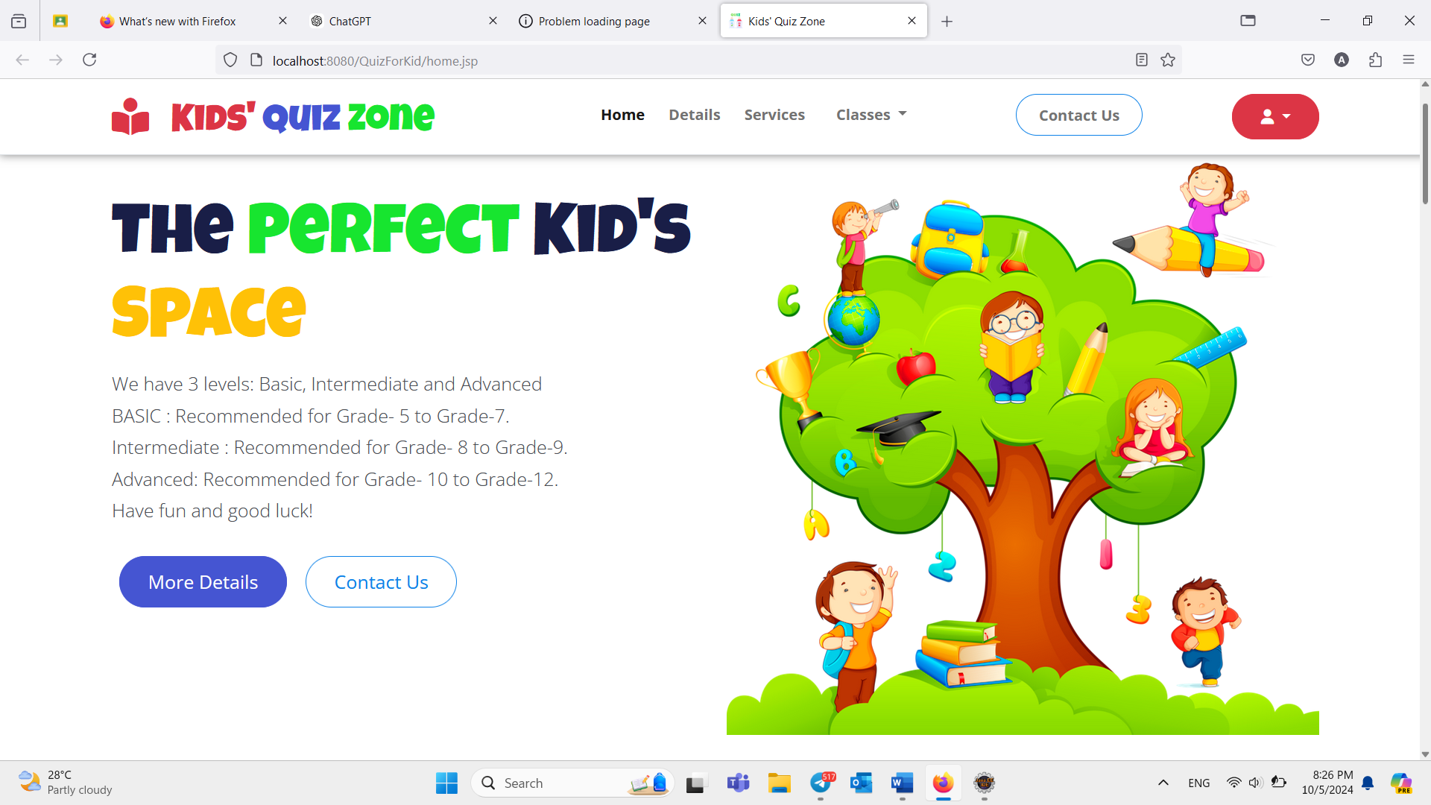

Figure 4.2.1 Home Page

When users visit the website, users will see the home page first. In this page users can see the overvierw of Kids’ Quiz Zone designs, services and others detail. The new users need to sign up and the already user can login to get the certificate and vist home page.

**4.2.2 Classes Page**

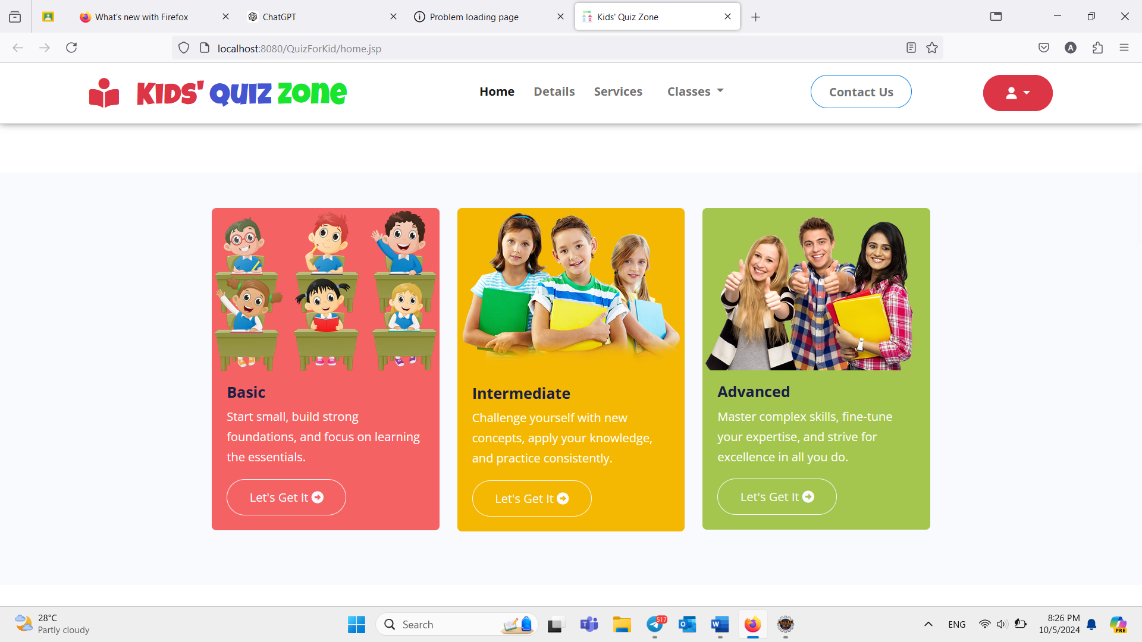

Figure 4.2.2 Classes Page

This page offers three levels—Basic, Intermediate, and Advanced—allowing users to choose the level they want to answer

**4.2.3 Details Page**

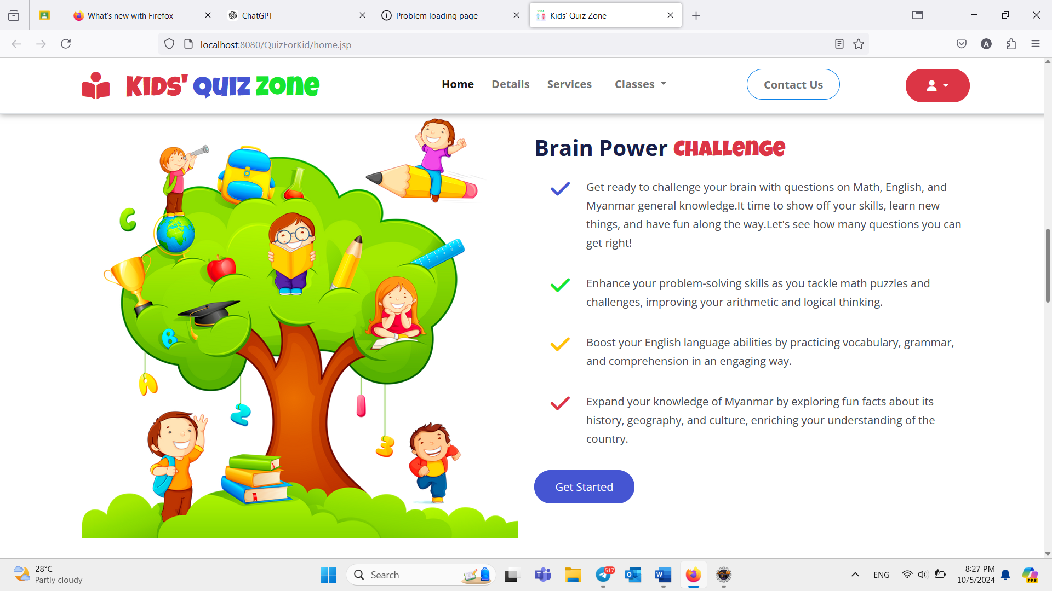

Figure 4.2.3 Details Page

On this details page, we provide a summary of the questions. By answering these questions on our website, you can improve your problem-solving skills and enhance your English language abilities.

**4.2.4 Service Page** 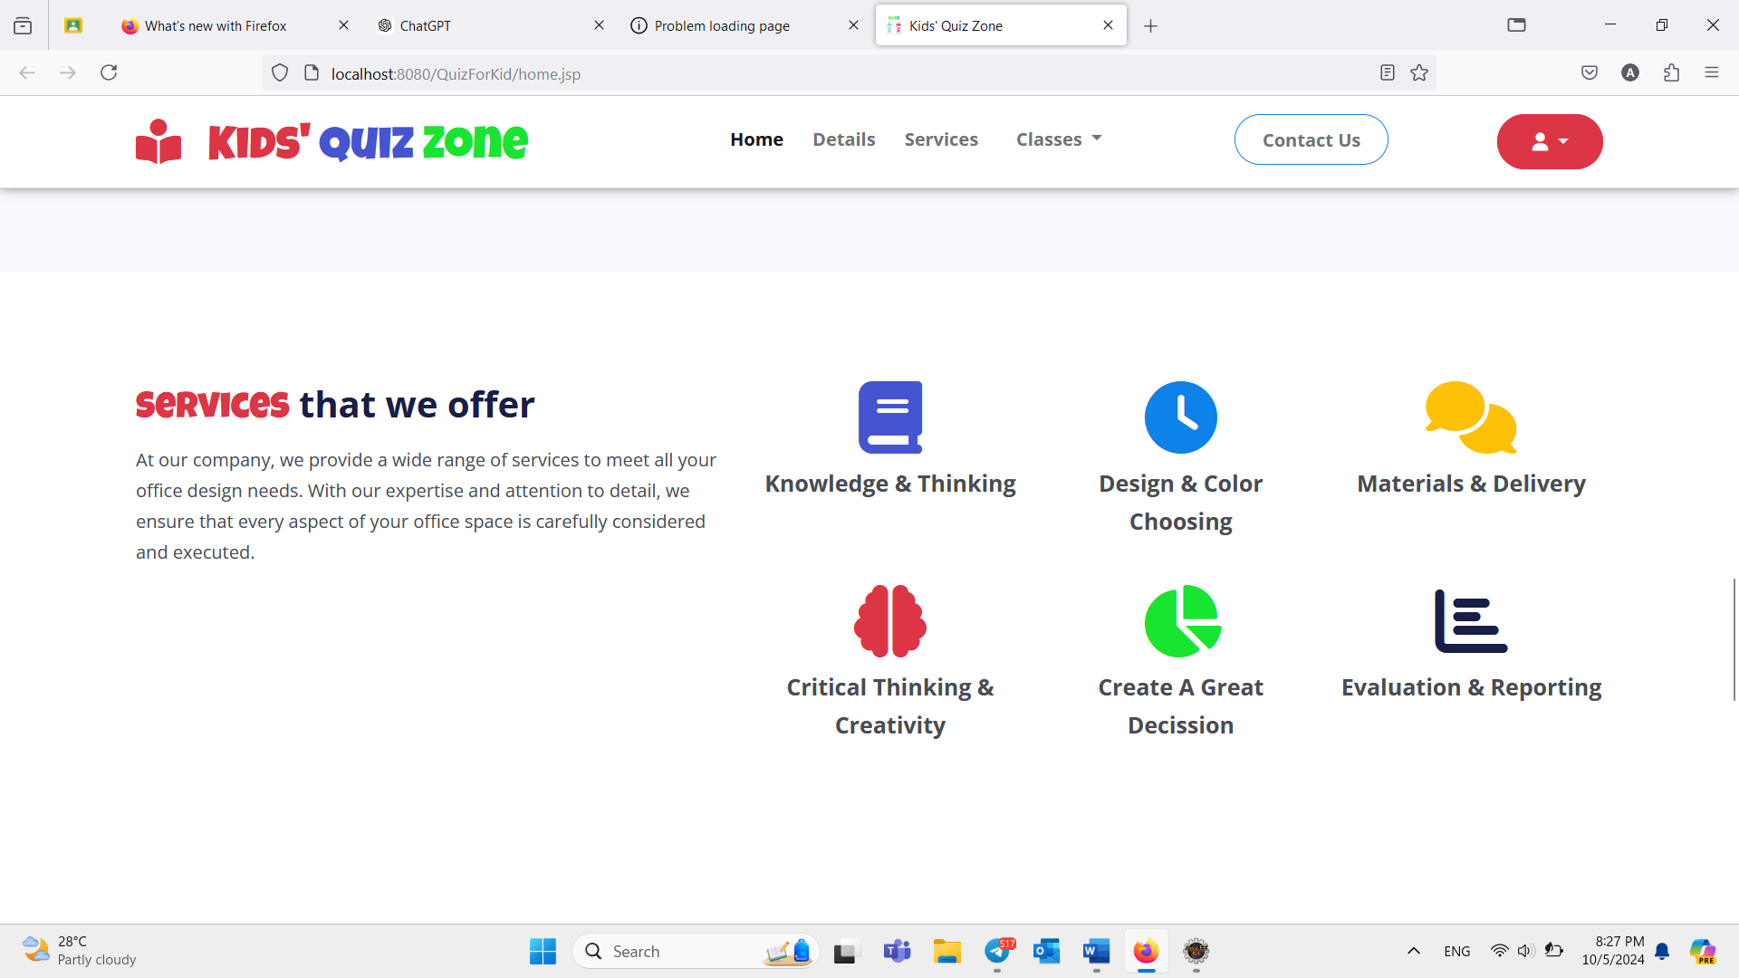

Figure 4.2.4 Service Page

On this service page, we offer a wide range of services to fulfill all your office design needs. With our expertise and attention to detail, we ensure that every aspect of your office space is thoughtfully planned and expertly executed.

**4.2.5 Contact Us Page**

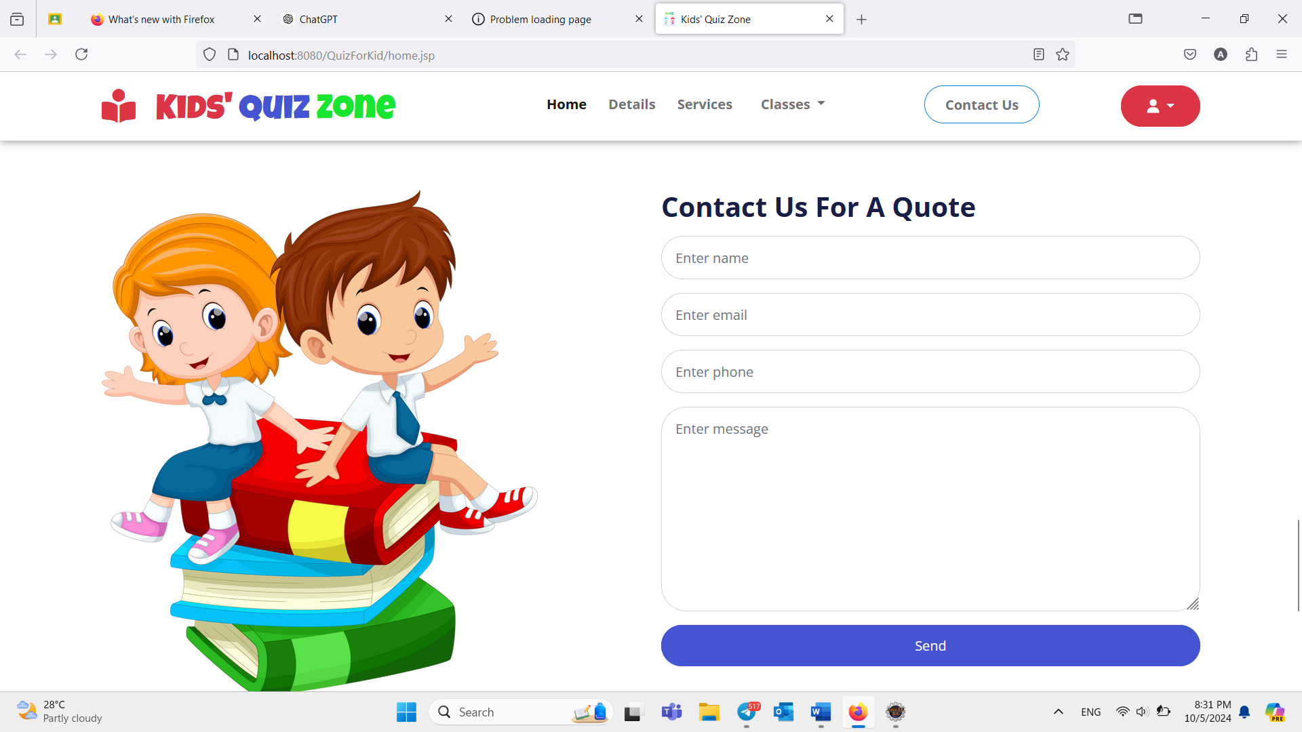

Figure 4.2.5 Contact Us Page

In "Contact us", users can get help with any issues they encounter while using the platform, such as technical difficulties, account problems, or quiz-related queries.

**4.2.6 Classes (DropDown)**

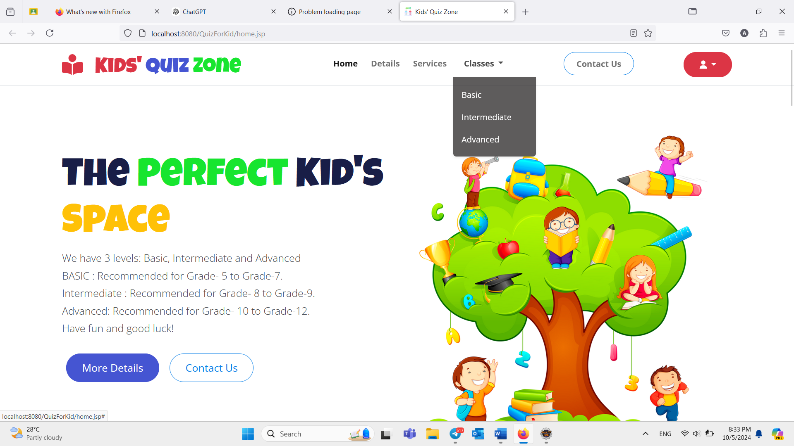

Figure 4.2.6 Class Dropdown

"Classes" includes three level( Basic, Intermediate,Advanced)

**4.2.7 Profile (login / Sign Up)**

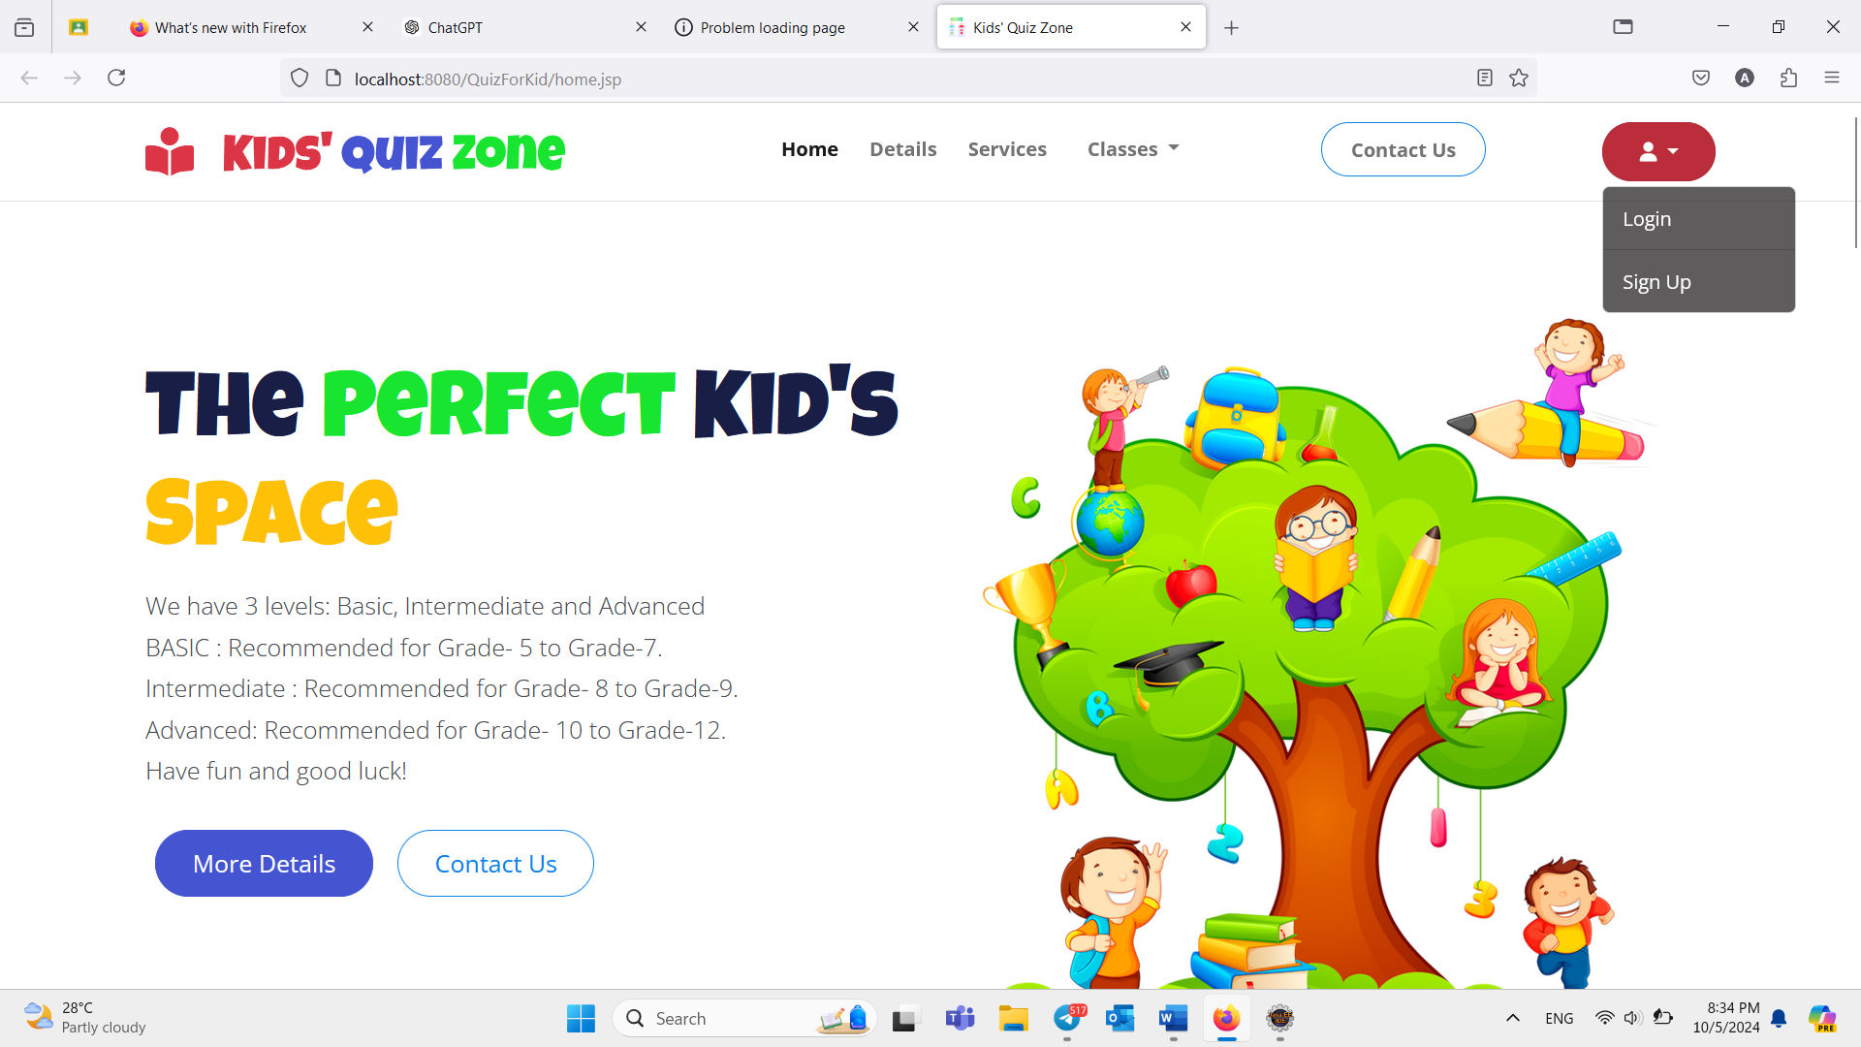

Figure 4.2.7 (Profile login / logout)

On this page, users who already have an account can login and use it, and users who don't have an account can signup to create account

**4.2.8 SignUp Page**

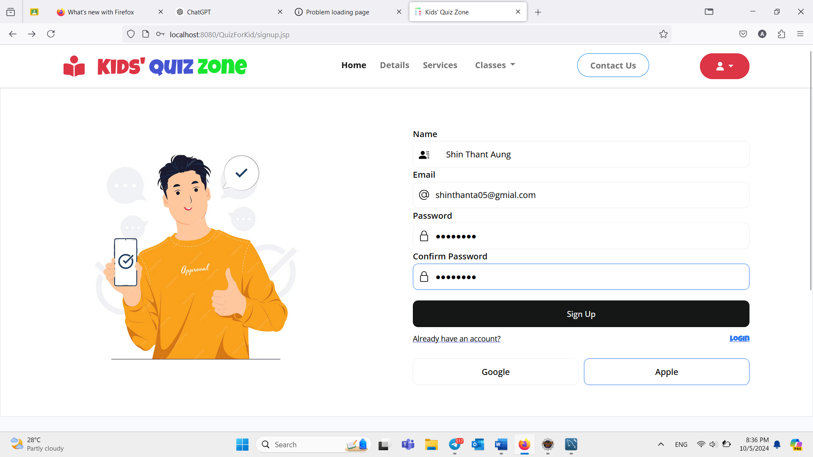

Figure 4.2.8 SignUp

On this page, if the user does not have an account yet, they can sign up and then log in afterward.

**4.2.9 Login Page**

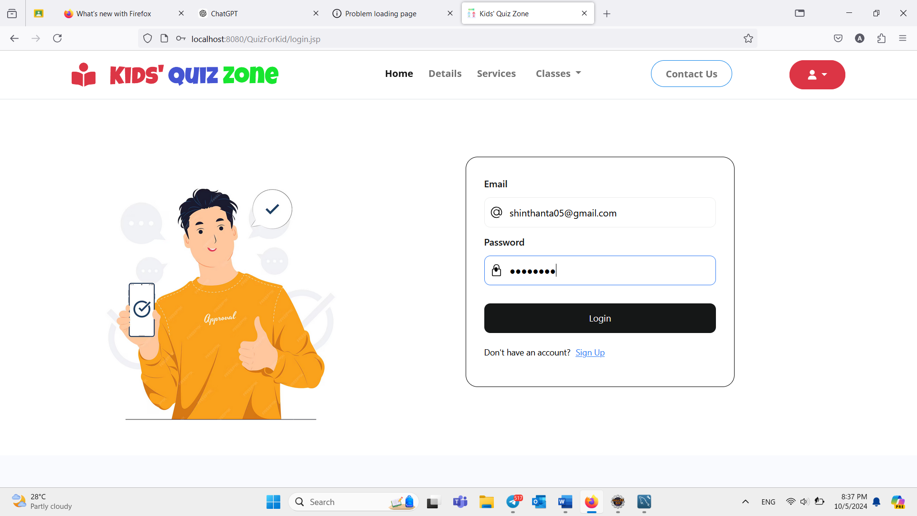

Figure 4.2.9 Login

"Login" allows users to login to their personal accounts using their credentials email and password.However, certificates are issued only after the user logs in.

**4.2.10 Quiz Questions Page**

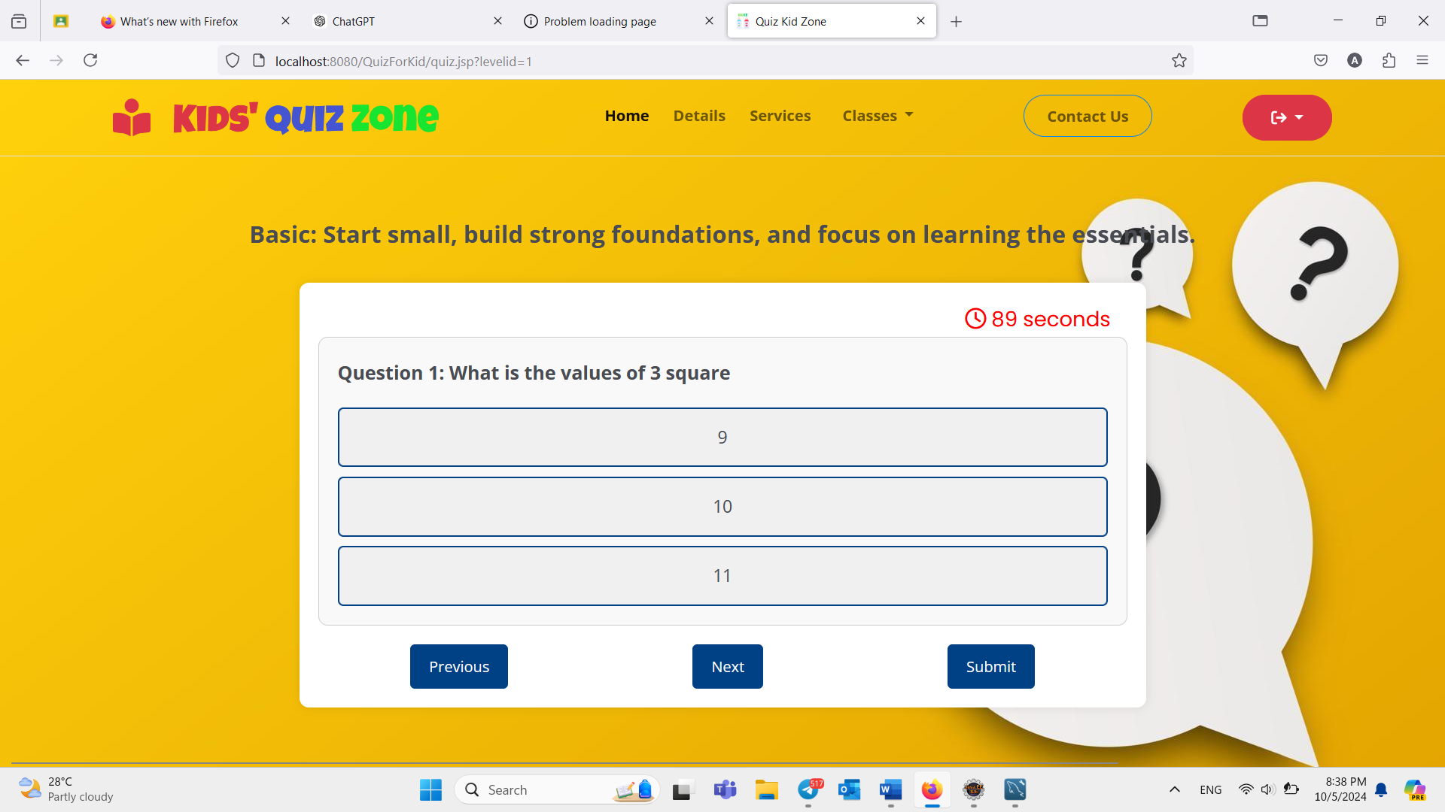

Figure 4.2.10 Quiz Questions Page

This page is for basic questions. You need to answer 15 questions within 90 Seconds. By clicking the 'Next' button, you'll move to the next question. After answering all the questions, click the 'Submit' button to view your score. Clicking 'Preview' will take you back to the questions you've already answered.

**4.2.11 Score Page**

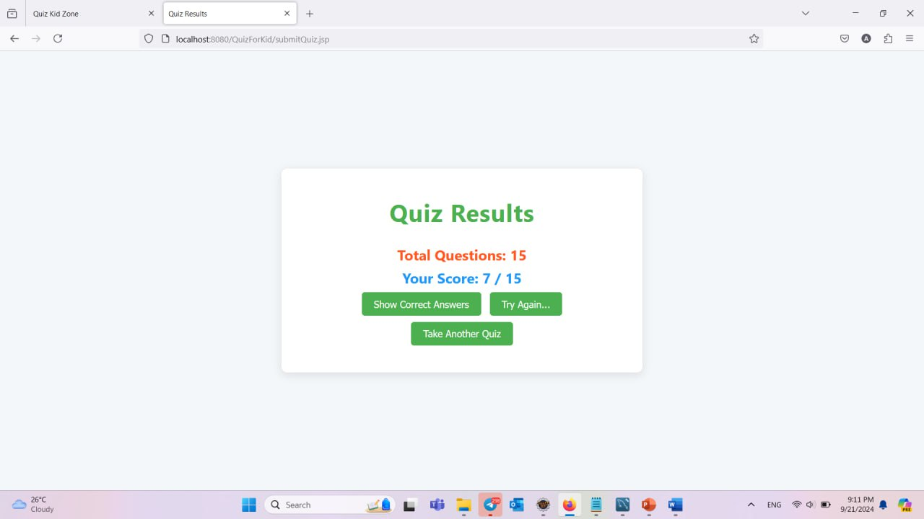

Figure 4.2.11 Score

After answering all the questions, your score will be displayed. If your score does not meet the required threshold, a certificate will not be issued. To obtain a certificate, click the 'Try Again' button and retake the quiz to achieve the necessary score. You can view the correct answers by clicking the 'Show Correct Answers' button.

**4.2.12 Correct Answer Page**

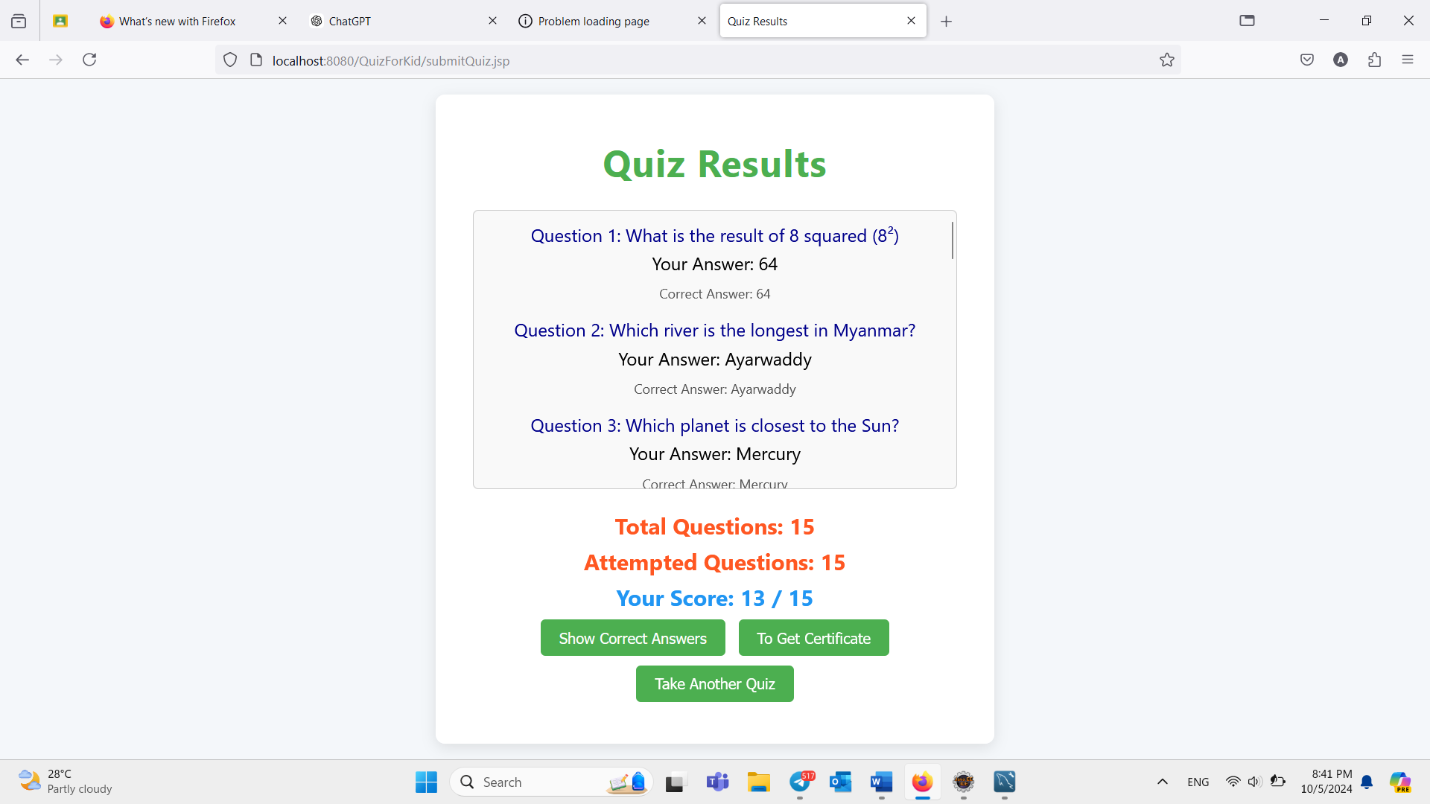

Figure 4.2.12 Correct Answer Page

If you click 'Show Correct Answers,' you can review the correct answers to the questions on this page. If you click 'Take Another Quiz,' you will return to the classes page

**4.2.13 Score Page (Certificate)**

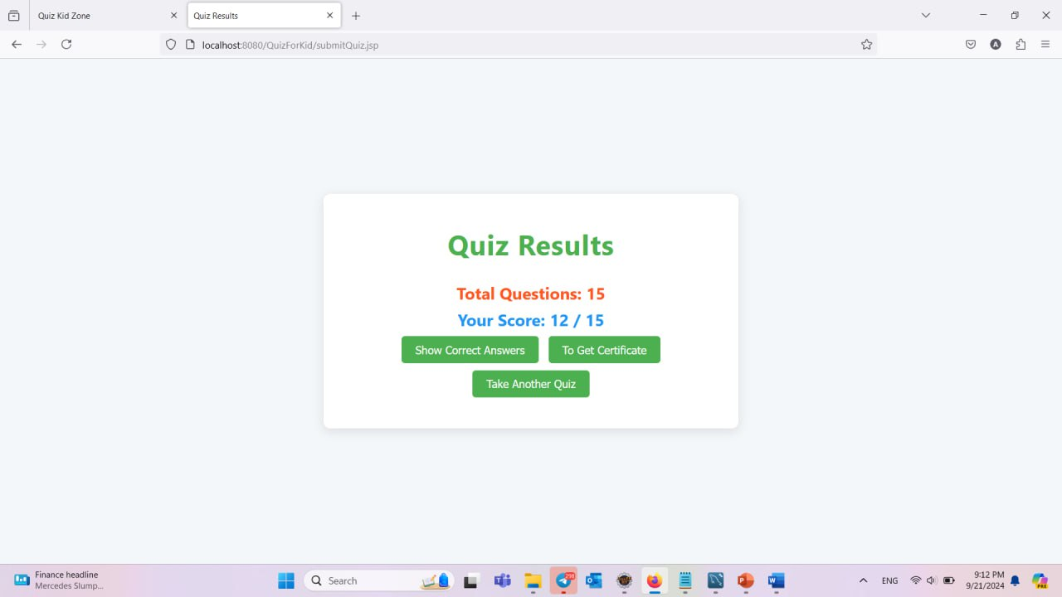

Figure 4.2.13 Score Page

If you get more than 10 marks, you will receive the certificate. Click “To Get Certificate” to get your certificate.

**4.2.14 Certificate Page**

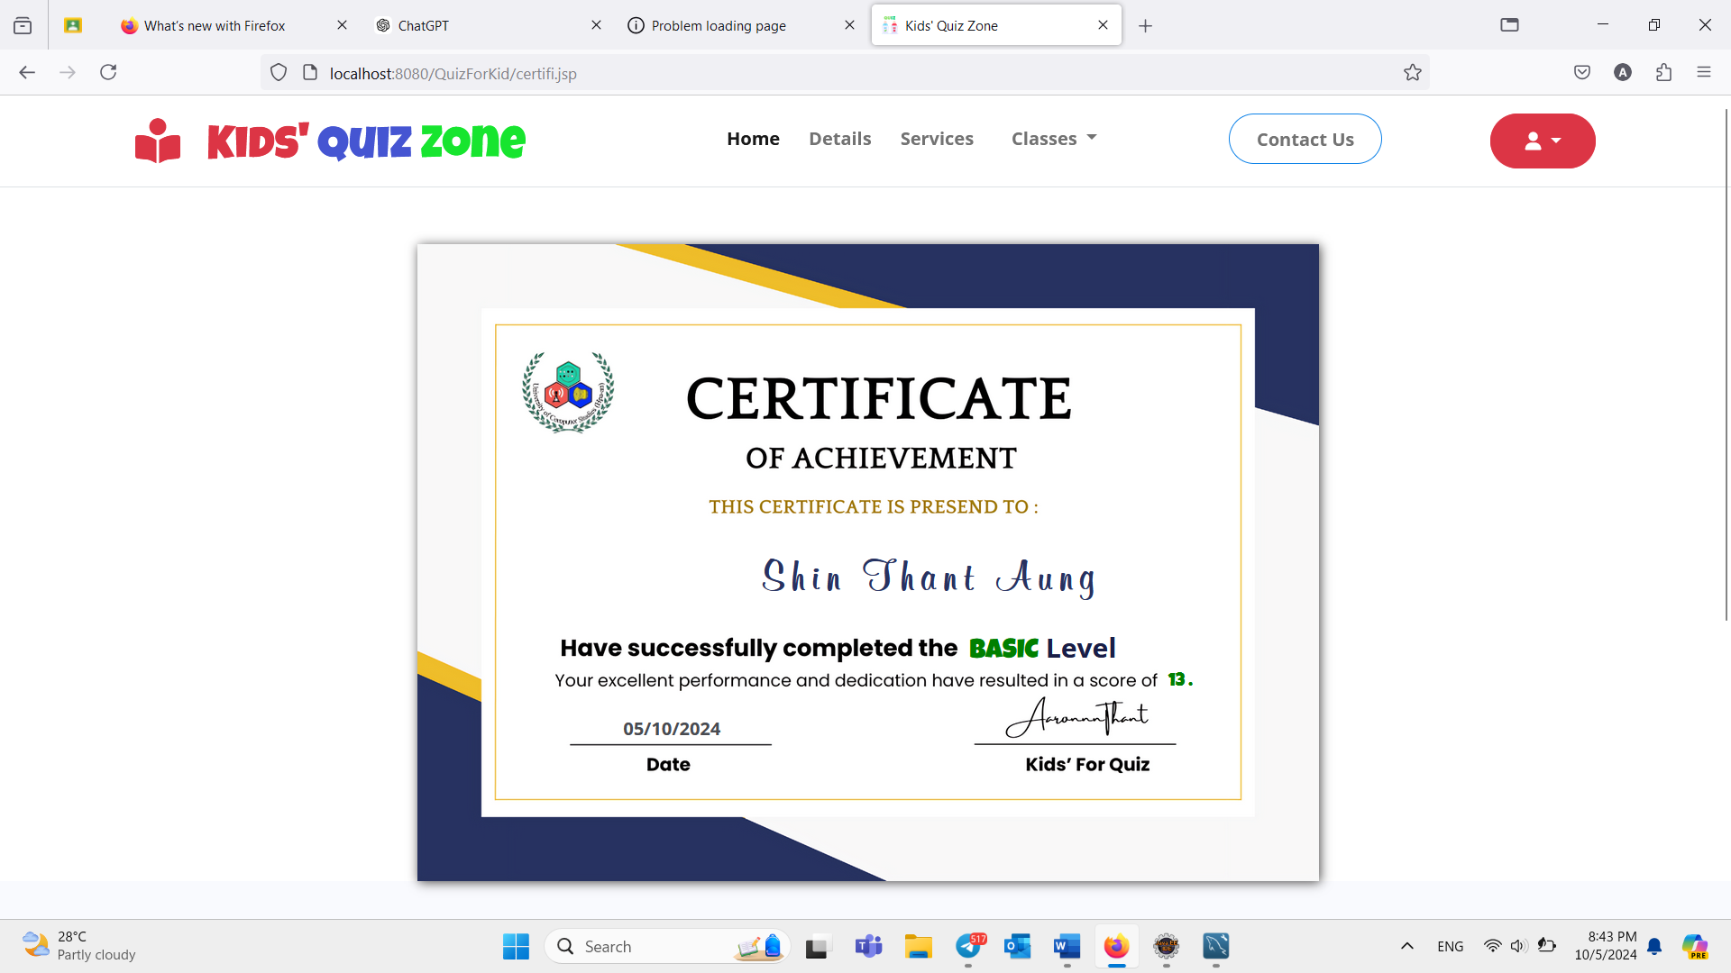

Figure 4.2.14 Certificate

On this page, users who get 10 or more points according to the relevant level can get a certificate and need to login to issue the certificate

**4.2.15 Admin Login Page**

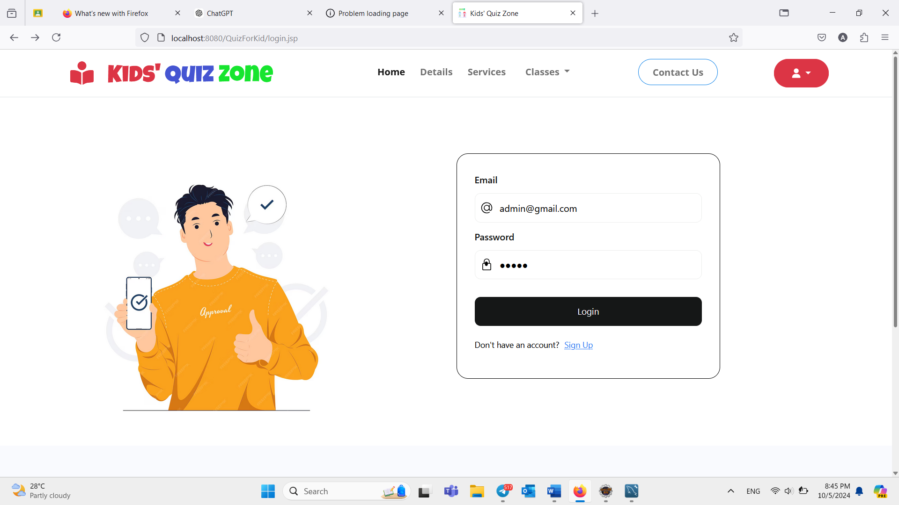

Figure 4.2.15 Admin Login Page

This login is for admins to access, manage questions, and view the user list.

**4.2.16 Admin Dash Board Page**

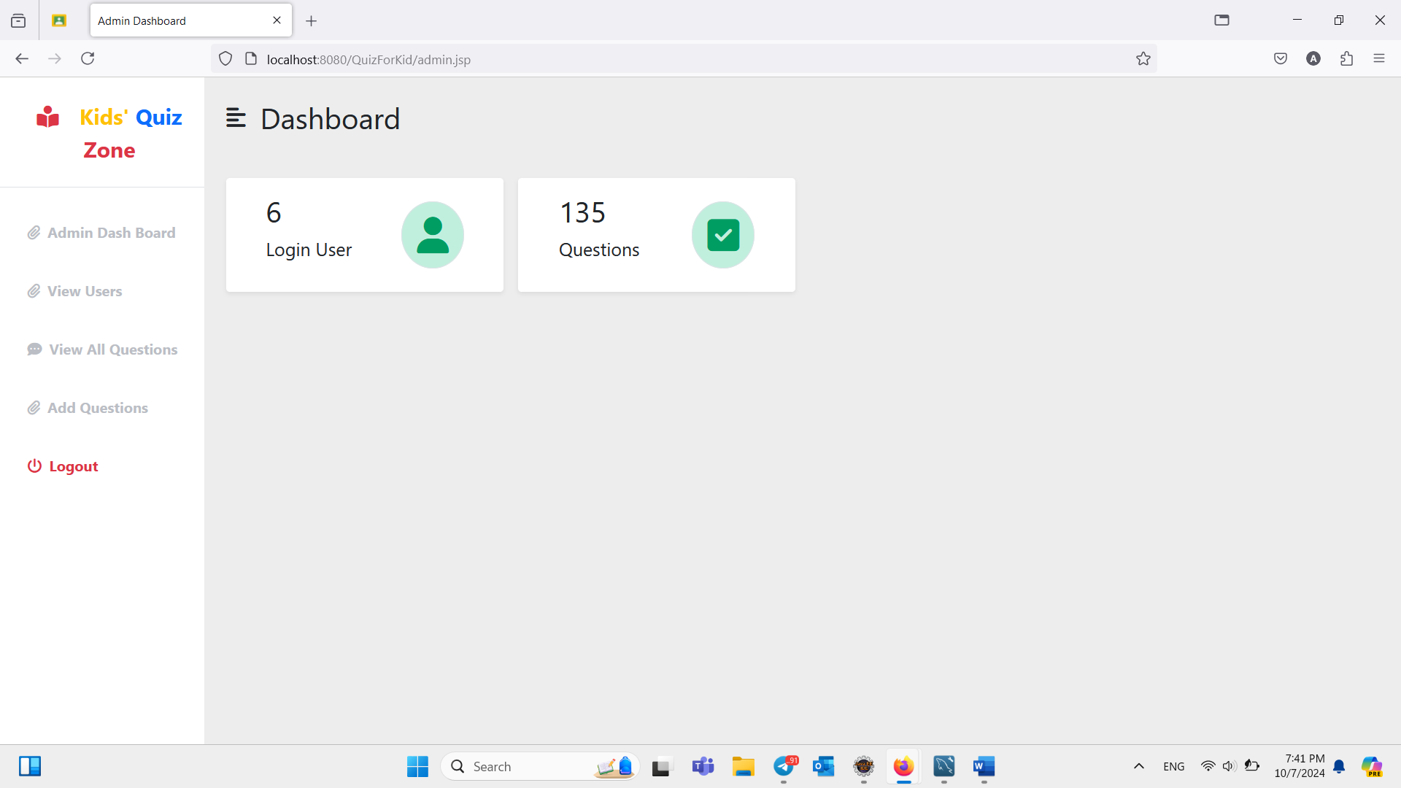

Figure 4.2.16 Admin Dash Board

This page is Admin Dash Board page, the admin can see all information and manage.

**4.2.17 Admin View (List of Users/ All Questions)**



Figure 4.2.17 View (List of User/All Questions)

On this page, the admin of Kids' Quiz Zone can view the logged-in users and the total number of questions.

**4.2.18 List of User Page**

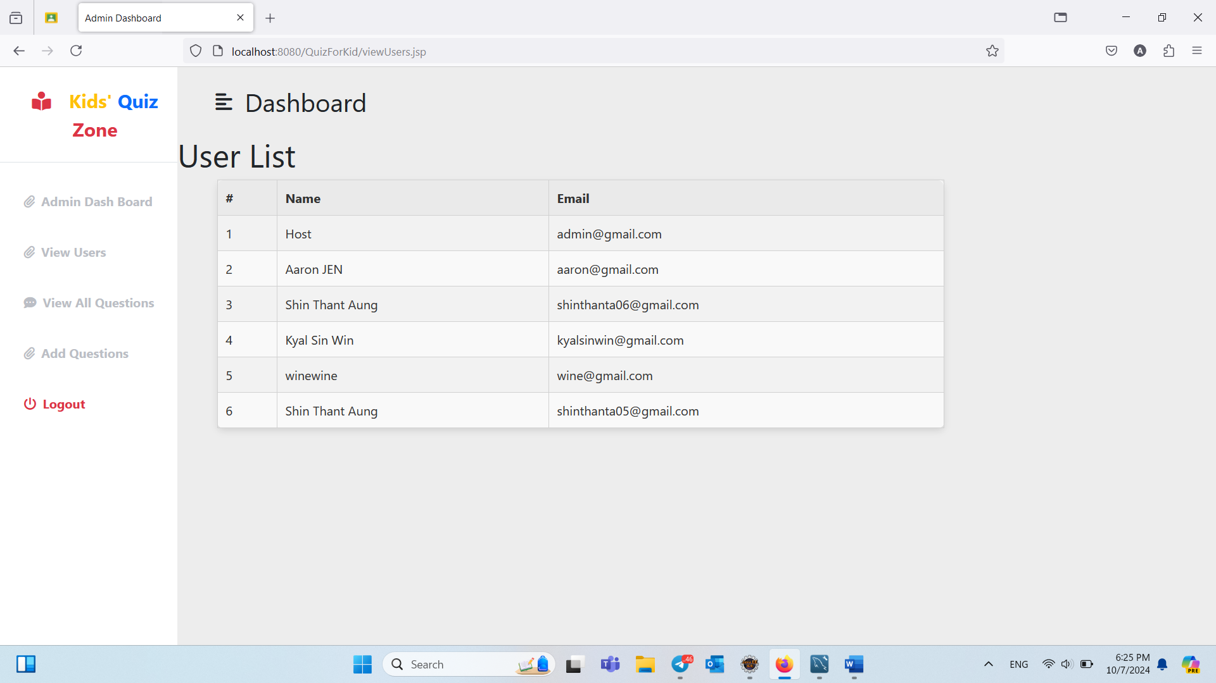

Figure 4.2.18 List of User Page

This is the List of Users page. On this page, the admin can view the information of logged-in users.

**4.2.19 All Questions Page**

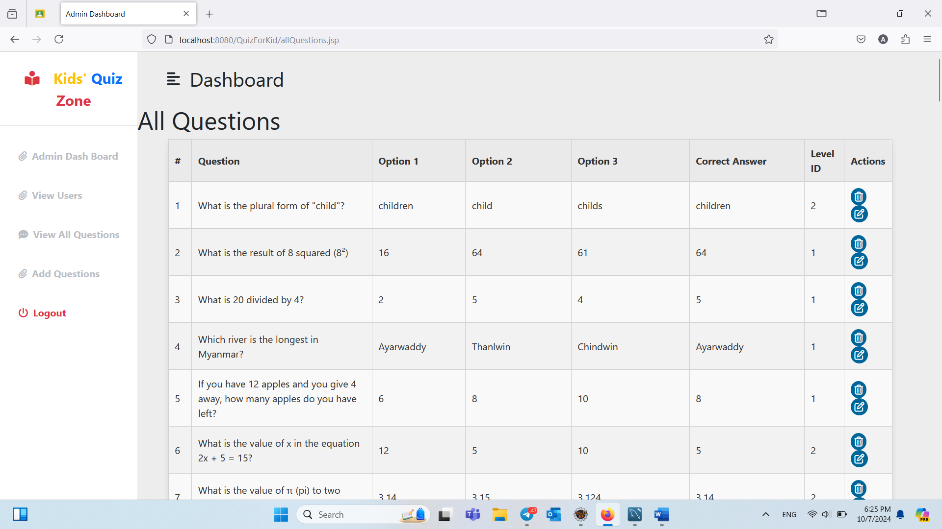

Figure 4.2.19 All Questions Page

This is the All Questions page. On this page, the admin can view, edit, and delete all the information.

**4.2.20 Edit Questions Page**

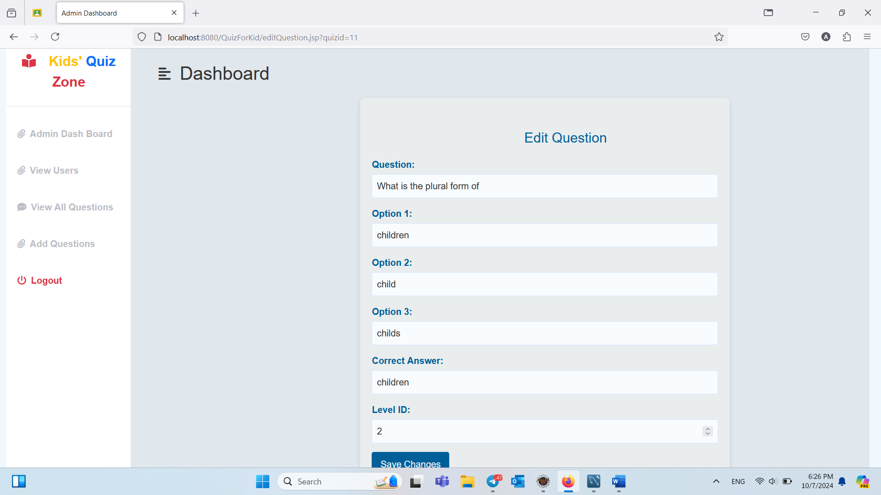

Figure 4.2.20 Edit Questions Page

This is the Edit Questions page, where the admin can modify questions and answers.

**4.2.21 Add Questions Page**

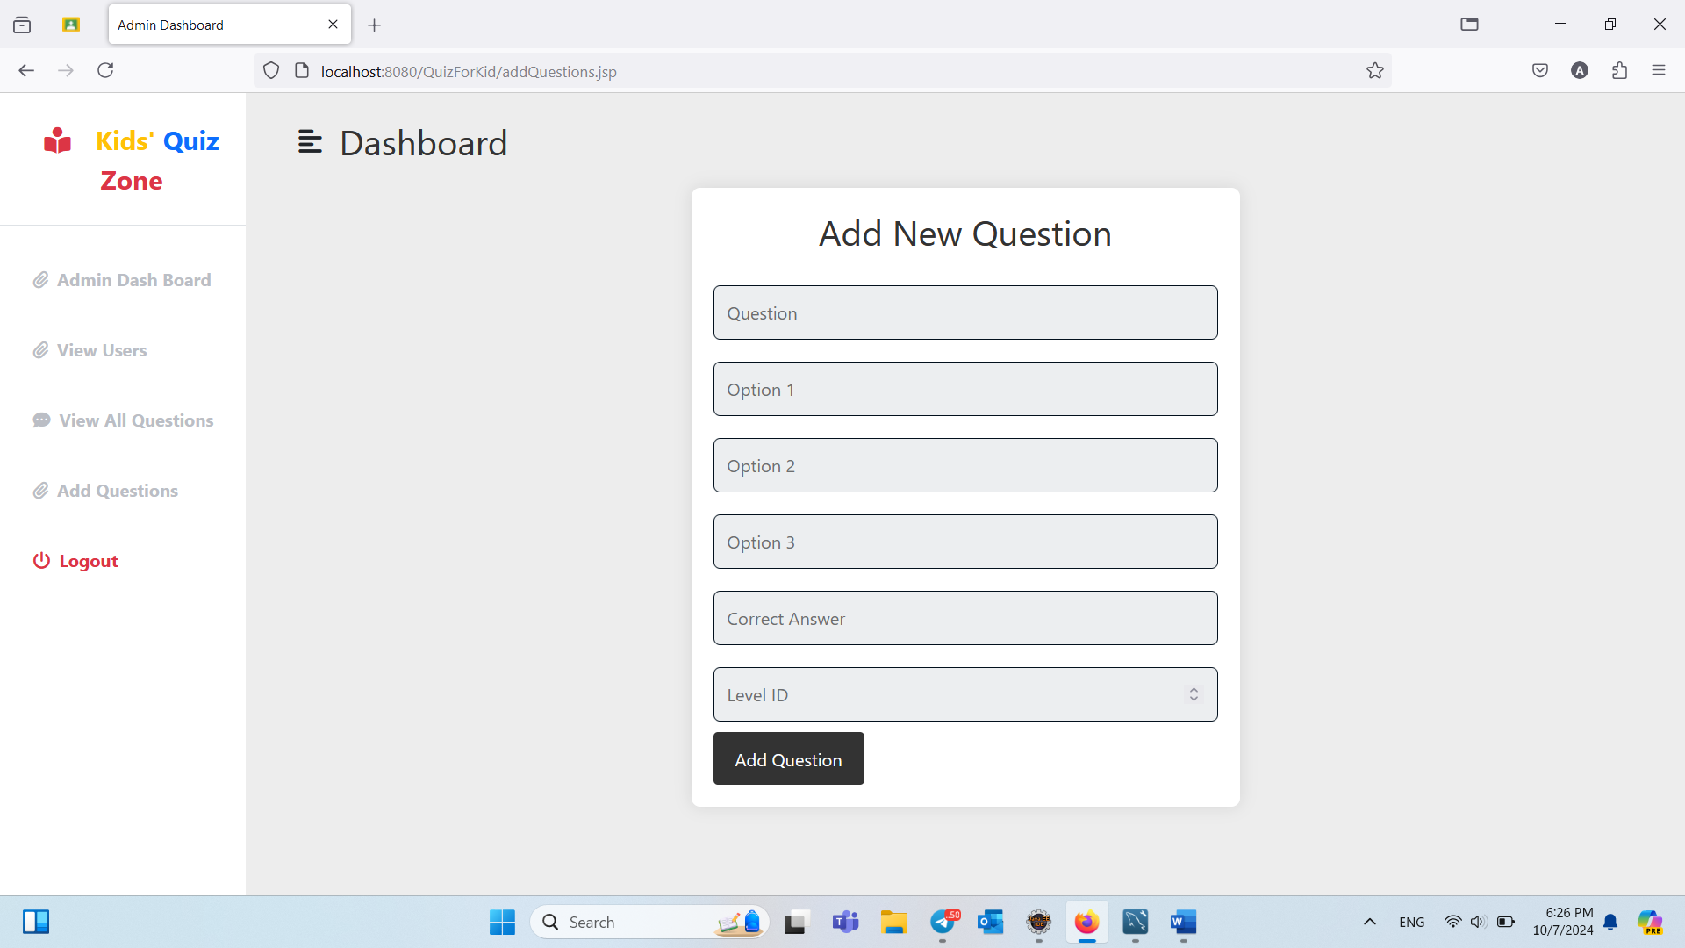

Figure 4.2.21 Add Questions Page

This is the Add Questions page, where the admin can create new questions and answers.

.

**CHAPTER-5**

**CONCLUSION**

**5.1 Conclusion**

The implementation of the **Kids’ Quiz Zone** project has significantly improved the accessibility and learning experience for children by providing an interactive and engaging platform for quiz-based education. The system’s features, including easy quiz navigation, real-time question feedback, and personalized result tracking, have enhanced user satisfaction and increased participation. Additionally, the seamless integration of user management, secure quiz handling, and an intuitive interface have made learning more enjoyable and effective. Overall, the **Kids’ Quiz Zone** project has successfully transformed traditional learning methods, playing a vital role in promoting educational growth and digital engagement for young learners.

**5.2 Limitation**

While the **Kids’ Quiz Zone** project offers a valuable platform for interactive learning, there are some limitations to consider: The quizzes may not cover all educational levels comprehensively, and certain topics may have limited depth or variety in questions. The accuracy of results relies on user input, and incorrect or incomplete answers may affect performance tracking. Users may occasionally encounter technical issues, such as slower loading times or minor interface glitches. Additionally, the platform currently lacks advanced features like adaptive quizzes or personalized learning recommendations based on individual user performance.

**5.3 Future Work**

We plan to implement features that offer personalized quiz recommendations based on user performance and preferences. We plan to improve the quality of our questions by incorporating more engaging formats, such as multimedia elements and scenario-based challenges. Future updates will include more interactive elements, such as leaderboards and multiplayer options to encourage friendly competition. We aim to add more quizzes with a wider variety of questions across different subjects and difficulty levels to cater to diverse interests.

REFERENCE

* [www.google.com](http://www.google.com)
* [www.w3school.com](http://www.w3school.com)
* [www.youtube.com](http://www.youtube.com)
* Java Sever Programming J2EE 1.4 Edition